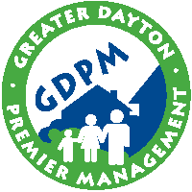
400 Wayne Avenue, Dayton, Ohio 45410
www.gdpm.org
HOUSING CHOICE VOUCHER
hcvprogram@gdpm.org
Main (937) 910-5400 • Fax (937) 910-5303
TDD 937-910-7570
Greater Dayton Premier Management
Enhancing Neighborhoods • Strengthening Communities • Changing Lives

ADMINISTRATIVE | ADMISSIONS
administration@gdpm.org
Main (937) 910-7500 • Fax (937) 222-3990
TDD 937-910-7570

Date

Tenant
Address
City, OH 45

Dear Valued Resident:

While reviewing your tenant file it was noticed that you have not completed the required community service hours mandated by HUD. Community Service for non-exempt family members is required by HUD and Greater Dayton Premier Management has to operate its housing programs based on HUD regulations. It is very important that you adhere to the guidelines regarding community service.

The good news is that we can offer you chance to catch up on your community service. You will need to sign the enclosed community service deficient hour’s agreement and return in enclosed envelope ONLY within 7 days. Once you sign the community service agreement you will have one year in which to submit any past due community service hours. You must still complete the current hours of 8 per month by submitting the tracking logs to your site office on a monthly basis. The failure to enter into this community service agreement may result in eviction actions initiated against you. Please call me with any questions.

Sincerely,
Andy Honnert
Asset Management Specialist
Wilkinson Plaza
Phone: 937-222-4207
Fax: 937-222-7668

